Zhixian Zhang (Chester)

VMS 240L

Professor Kate Alexandrite

06 November 2022

I decide to expand my midterm project to my final. I want to add a navigation page for the ski resort recommendation page, in which I will include a clickable map for the audiences to click on the states they want to explore. After the midterm critique about my project, some classmates had some valuable suggestions of adding a navigation page for this website, as well as listing the reasons why I chose these four states on my website and why I have these rankings for the ski resorts on my website. So, I think adding an interactive map in the navigation page is a good choice. It can be more clear and intuitive for the audience to see where they are going and why they are going to those places. Currently, the website only displays the name of the states without the location. So people may easily get geographically confused, especially for people ski in the U.S. for the first time.

When it comes to the social influences about this webpage, I think the current page do has some aspects to be modified. I didn’t include the reason why I chose these four states to present and why I chose these resorts to recommend. This may disappoint people who didn’t see their home states or their favorite resort showing up on the website. So I will add some comments or references to the audiences explaining the rationale behind choosing these resorts. Also, I will extend my website to recommend not only within four states in the U.S. but also more states so I can take care of more people’s feelings.

When it comes to accessibility, I will add the readable feature for the webpage to provide accessibility for visually impaired people. When the mouse hovers on a clickable button, for example, on a state in the map, the website will read out aloud the name of the state. I hope this is helpful for making my website more accessible to more people.

My final project will have a navigation page at the first page, with an interactive map that audiences can click on the states they want to explore. Since not all the states in the U.S. have ski resorts, not every part of the map is clickable. But the states that are clickable will be easily recognized by the audience using some color difference. The navigation page will also have a short explanation about why not every part of the map is clickable (for not offending people in those states). When hovering on a clickable state, the website will read the name of the state for people have difficulties to see the website. After clicking into a state, the website will jump to a page that is similar to my midterm project, which is the recommendation for ski resorts. But this time the page will also display the reason or the references why I chose these four ski resorts to recommend. Also, the recommendation page will have the readable function. Where ever the mouse is hovering on a text, the webpage will read the text out loud. Besides, there is a button for closing the readable function.

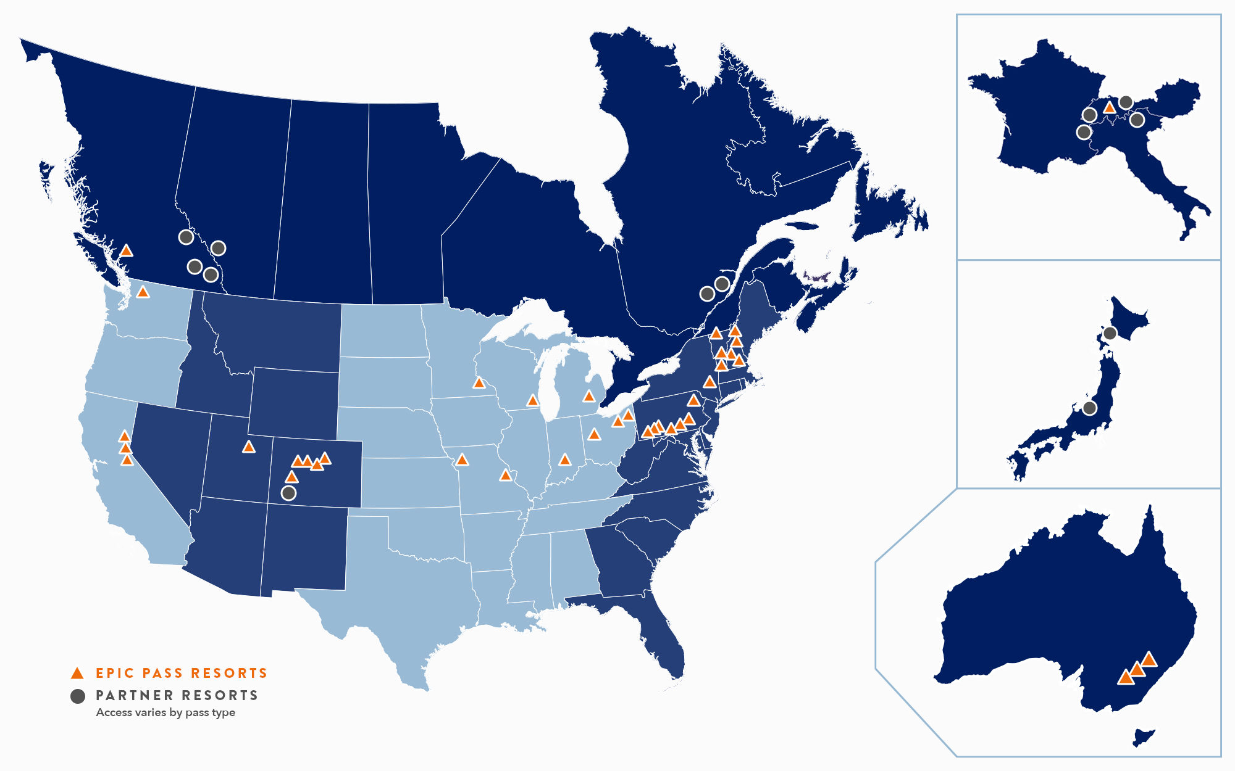

<https://www.snow.com/>

This is a website for selling their season passes and the map indicates the ski resorts under their coverage. This is not a clickable map, however the design somehow meets my imagination of what I want to do.

<https://www.snow-online.com/map#z=3.4703039786219607&lon=-94.68603942002247&lat=46.62160944006769>

This is another website that inspires me. It indicates where do ski resorts locate and how many of them are there. Also, when I click an ikon, the map will zoom in, which is very cool. I am curious about how to realize it.

Timeline:

Nov.9: Sketch of design for navigation page finalized

Nov.14: Research Presentation. (Clickable maps, hovering readable contents)

Nov.16: Clickable map in processing, recommendation pages processing.

Nov.21: Clickable map and recommendation pages finalized, readable contents processing.

Nov.30: Readable contents finalized, project uploaded and live.